Handout 1
Course Overview

1. Syllabus Overview

2. The Big Picture

3. Probability Overview

4. Actionable Items

5. Appendix – Canvas in API-209

Syllabus Overview
Goal: To prepare you to use statistics to analyze and inform public policy issues.

Ultimate goal: Help you develop an empirical approach to life

Types of policy questions you will be able to tackle by the end of this course
- Should women in their 40s have annual mammograms?
- How can we assess the targeting effectiveness of a pension program in Mexico?
- Was there fraud in an election?
- What is the impact of solar lanterns on the lives of rural Ugandans?
- Which workplaces should a safety agency inspect?

Main features of the course
- Conceptual emphasis
- Greater link between inferential statistics and regression analysis
- Use of statistical tools in the policy world (mandatory testing for a disease, assessing discrimination, evaluating a social program, etc.)
- Inclusion of new topics (decision analysis, sampling, statistical power, prediction)
- Use of R
- Use of real data sets

Logistics
- Teaching Approach
- Teaching Team
- Communication
  - Slack: general questions
  - Email: long individual questions
- Key Resources
  - Handouts
  - Pre-Class Exercises (PCEs)
  - Office Hours
  - TF Sessions
  - Course Website (Canvas)
- Expectations
- Feedback
- Enrollment for non-MPA/IDs

Grading
- Class participation and engagement
  - Engagement in class
  - Engagement outside of class
- Pre-Class Exercises (PCEs)
- Academic honesty
- Generative AI guidelines

The Big Picture
- Goal: To prepare you to use statistics to analyze and inform public policy issues.
- In this course, we will focus on three broad uses of statistics:
  - Descriptive: Describes some aspect of the world. Aim is to characterize or understand a problem/issue
  - Causal: Aims at assessing causal effects.
  - Predictive: Aims at predicting an outcome, independent of causality.

Use is driven by question of interest…

1 – Descriptive Use | 2 – Causal Use | 3 – Predictive Use
What are the characteristics of poor households in India? | What is the effect of a microfinance program in India on poverty? | Who will be poor in India next year?
What are the key patterns of economic growth in the world in the past 30 years? | What is the effect of economic growth on inequality? | Which countries will grow the most over the next 5 years?

Your examples

1 - Descriptive Use

2 - Causal Use

3 - Predictive Use

- One key framework that we will use in the course is statistical inference
  - The goal of statistical inference is to learn something about a population using a sample drawn from that population
- The underlying foundation of statistical inference is probability.
- So we start the course studying probability

API-209: Broad Roadmap of the Course

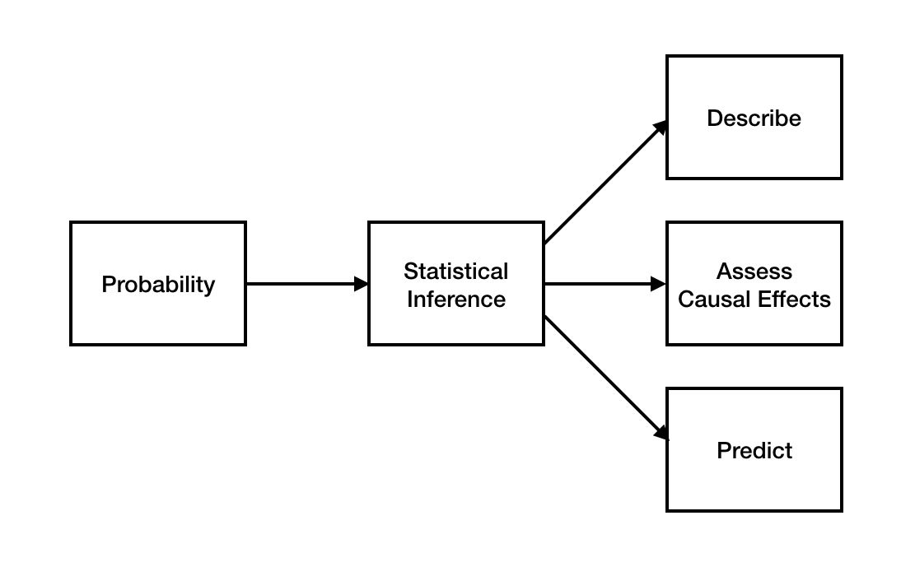

Probability Overview

Why study probability?

Some policy questions we will examine in this course that will use probability:
- Should women in their 40s have annual mammograms?
- How can we assess the targeting effectiveness of a pension program in Mexico?

CERTAINTY IS AN ILLUSION
- We begin by recognizing that the world is full of uncertainty.

- Yet far too many people (often experts) believe things for certain that are just not so. Examples:
  - People who thought Narendra Modi would win the 2024 elections in India by a landslide
  - Doctors when giving diagnoses based on test results
  - Other examples?

Principle #1: The world is much more uncertain than you think

MEASURING UNCERTAINTY
- Most decisions we face in the world involve uncertainty.
- Most pieces of evidence we gather are subject to uncertainty.
- Assessing probabilities is the process we use to try to measure this uncertainty. We will try doing this soon.

Thinking probabilistically about the world

A broad goal of this segment of the course is that you increasingly think about the world in probabilistic terms. Thinking probabilistically about the world is one of the maxims I hope you will adopt in your professional and personal life.

Thinking probabilistically about the world involves three distinct elements:
1) Understanding what these subjective probabilities actually mean,
2) Assigning probabilities to many things (events, beliefs, etc.) in our lives, to help us better understand the world around us and make better decisions, and
3) Updating these probabilities appropriately when relevant new information comes in.

Key elements of thinking probabilistically about the world

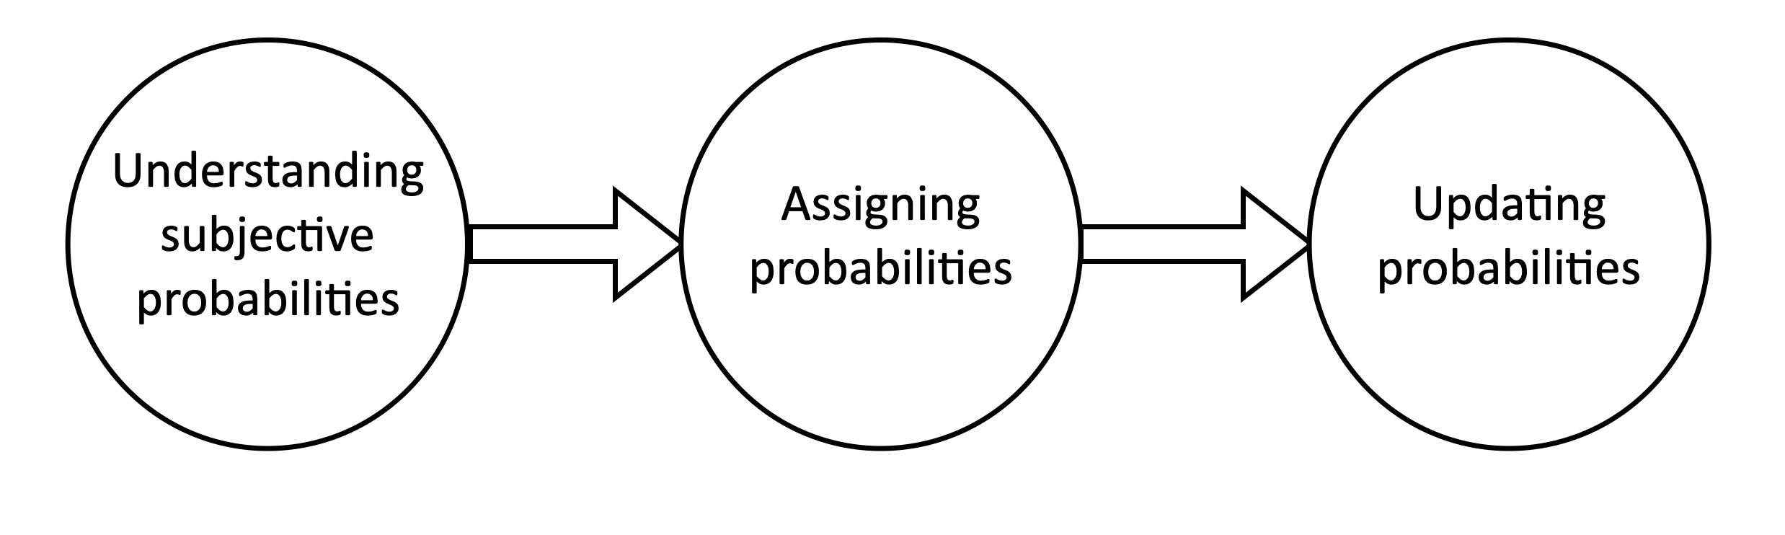
Source: "Maxims for Thinking Analytically: The wisdom of legendary Harvard Professor Richard Zeckhauser" by Dan Levy

Example - A Birthday Puzzle

What is the probability that at least two people in a group of 20 people will have the same birthday?

Answer based on your “gut feeling” (circle the option that you think is the correct range):
- Less than 1%
- Between 1% and 5%
- Between 5% and 20%
- Between 20% and 40%
- Greater than 40%

Assumptions:

Same birthday means same day and month, not necessarily same year

Assume that the birthdays of the 20 people are unrelated. For example, no twins allowed.

Each of the 365 days of the year is equally likely to be the birthday of any one person in the group.

For anyone born on February 29 will consider his birthday to be another day, say March 1.

Answer based on probability theory:

Principle #2:

Actionable Items
- Pre-Class Exercise about medical testing (due this Thursday at 7:00 AM)
- Problem set #1 (due on Thursday of next week at 7:00 AM):
  - Requires use of R
  - Mexico Pensions for the Poor

Appendix – Canvas in API-209
Home page contains links to the key info you need about the course:

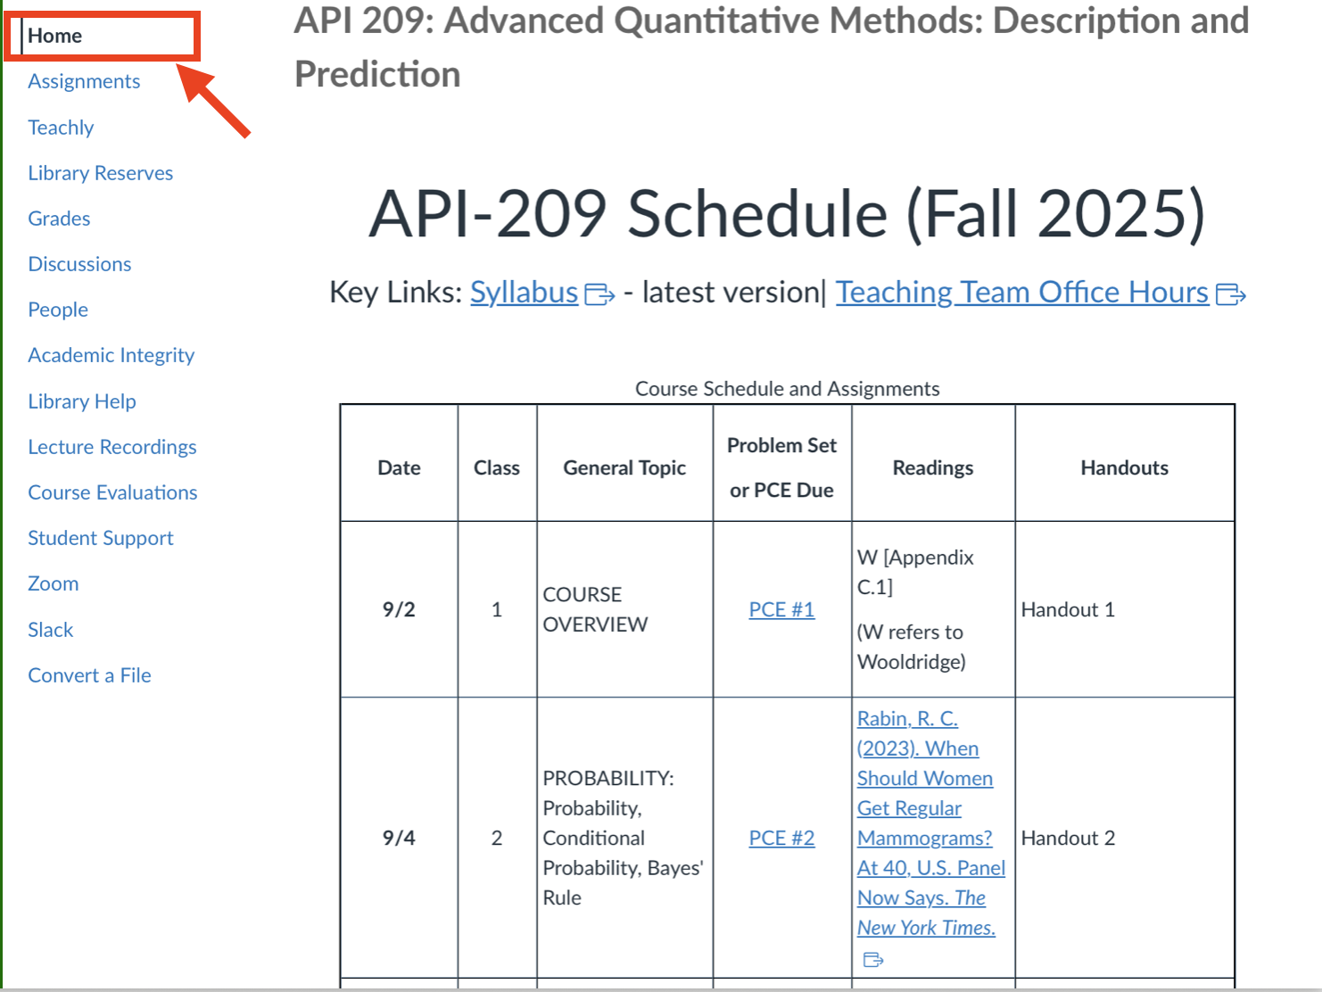

Note: This course will assume a working knowledge of probability theory, as reflected in the math camp material of Prof. Deb Hughes Hallett. The background material column of the course schedule (located in the syllabus) contains the key concepts needed for each class.
Some of this section is based on “Risk Savvy: How to Make Good Decisions” by Gerd Gigerenzer (2014).
I owe this maxim to my colleague, mentor and friend, HKS professor Richard Zeckhauser.

